Chapter 3: Experimental tools
  - Machining center
The tool path used in incremental forming is the same as the G code used by normal machine tools. Therefore, incremental forming can be done by customizing a machining center without purchasing a dedicated machine. In this study, a general-purpose machining center, a precision linear nano machining center (MC430L) from Sodick Co., Ltd was used. By attaching an incremental forming device and an oil bath to this machining center , it became possible to perform incremental forming. The figure bellow shows what the machine center looks like.
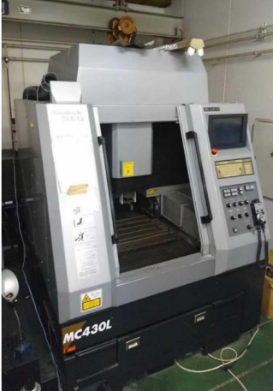
Figure 3.1: Appearance of M C430L

  - Python
As mentioned in a previous section, Python is an open-source programming language known for its simplicity, readability, and versatility. It's widely used in fields like data science, web development, automation, machine learning, and computing. The easy accessibility, simple syntax, and large amount of libraries that help with specific tasks are some of the reasons why it will be used in this research.
As mentioned before, Python is used to build a CAM system that will take STL data and generate G-code for CNC machining.
  - Discontinuous CFRTP
As mentioned earlier in this paper, this study will be using discontinuous CFRTP as the test material. The integrated structure, random orientation of the fibers, and high press fomability are all reasons for the use of discontinuous CFRTP. The CFRTP sheets that will be used are (PA6 matrix, 20 wt% carbon fiber), the dimensions will be Size: 110 mm × 110 mm × 1 mm, and it will be dried at 120°C for 24 hours using an ETTAS oven to prevent moisture-induced degradation during the incremental forming.
  - Oil bath
The oil bath that will be used in this experiment is the oil bath that was used in the previous experiment, the T-22H model (Thomas Scientific). The oil bath can reach temperatures up to 200°C, has a precision of ±0.2°C and uses jet circulation to move the oil around ensuring that the heat of the oil is uniform.

  - Type of oil
    - The silicone oil used is Shin-Etsu Chemical's K F968 . The liquid used in the oil bath must be resistant to temperatures between 323K and 473K due to the characteristics of the sample . It is also necessary to ensure safety during experiments.
    - -High temperature resistance
      - Low thermal degradation (anti-spontaneous combustion )
      - Low volatility
    - This oil is used to satisfy the above points. The appearance is shown in Figure 3.4 below, and the specifications are shown in Table 3.4 .


Figure 3.2: Shin-Etsu Chemical KF968 oil that is used.

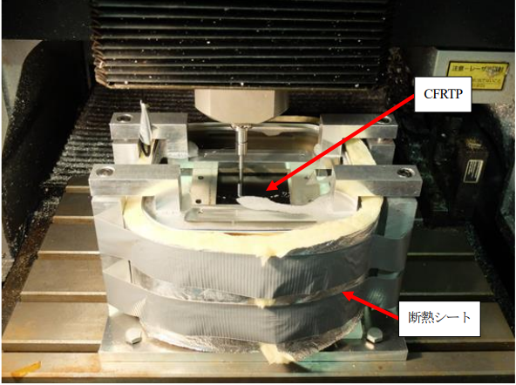

Figure 3.3: Incremental stretch forming with hot water assistance in oil bath (2017 )

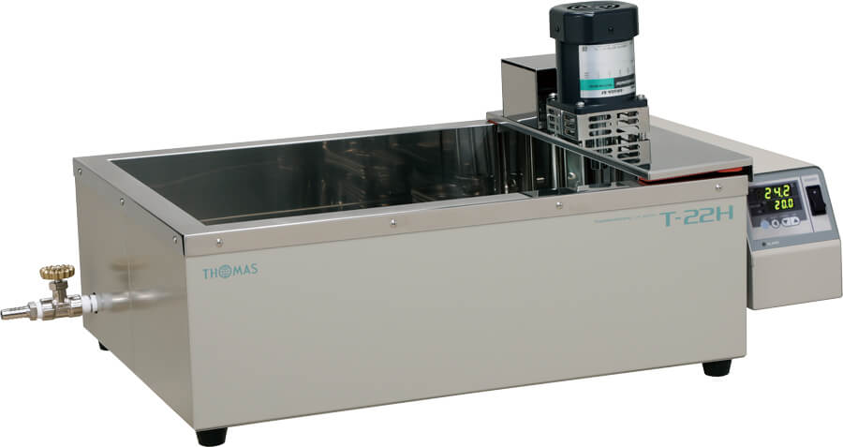
Figure 3.4: Appearance of T -22H

  - Forming tool
In this study, a 5 mm diameter rod with a 2.5 mm rounded tip was used as the tool. The mandrel diameter was the same as that of the mandrel used in the previous study. In addition, due to the offset of the incremental forming device attached to the machining center, the length of the rod was set to 60 mm. The material was SUS304.

  - Master mold
To prove that the shape could be manufactured using incremental forming, a preliminary test was done using a 3D printed mold and will be briefly mentioned in a later chapter as this is an important step but not the focus of this paper
  - CFRTP dryer
When the base material resin is heated, deterioration of the resin is expected at high temperatures. It is known that the presence of water in the material has a large effect on deterioration. PA6 resin, the base material used in this study, is also hygroscopic, so the CFRTP must be thoroughly dried before processing to remove the chance of deterioration. To achieve this, the ETTAS MOV-450S from AS ONE Corporation was used to dry the CFRTP. In the figure below the ETTAS is shown. The ETTAS can be set from room temperature to about 240 K and is the size of the oi heating area is 445 mm x 440 mm x 650 mm.
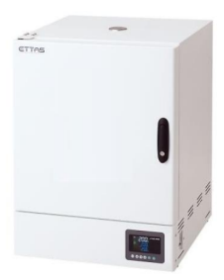
Figure 3.5: Appearance of the constant temperature dryer
  - Jig Dimensions
To hold the CFRTP and oil in place while forming, a Jig is required. The upper frame of the jig is removable and is able to secure the CFRTP. This improves work efficiency and safety. In Figure X we the dimensions are shown and in Figure X what the jig looks like is shown.
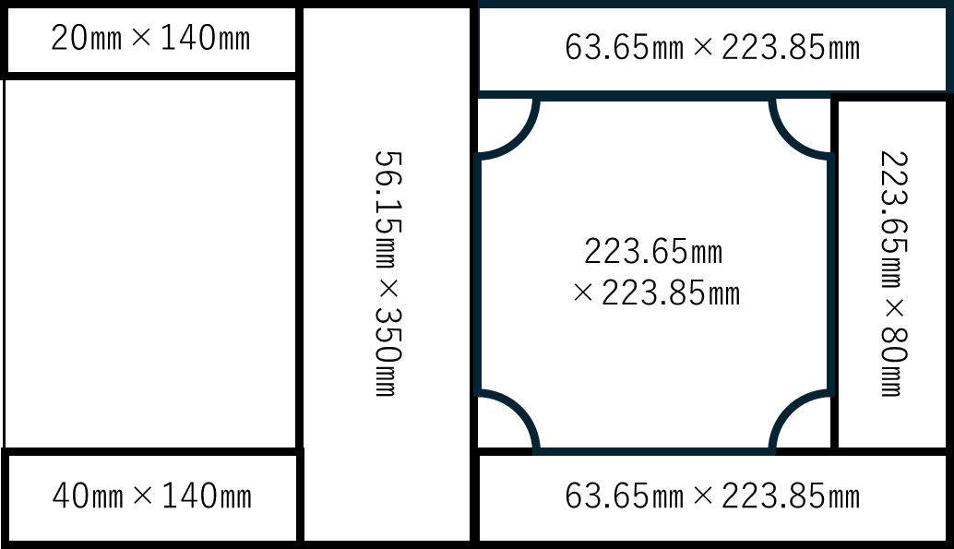
Figure 3.6: Jig dimensions

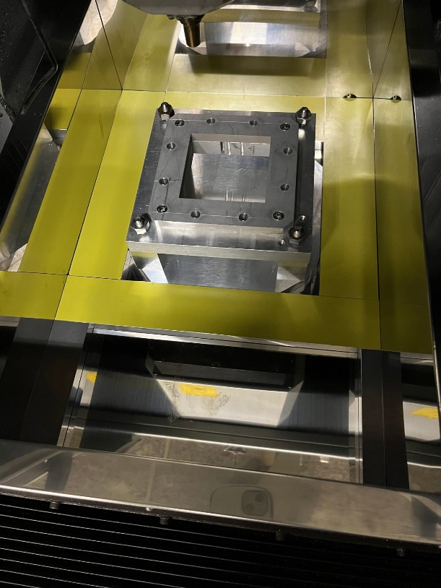
Figure 3.7: Jig arrangement (actual)

